**Topics: Confidence Intervals**

1. For each of the following statements, indicate whether it is True/False. If false, explain why.
2. The sample size of the survey should at least be a fixed percentage of the population size in order to produce representative results.

True

1. The sampling frame is a list of every item that appears in a survey sample, including those that did not respond to questions.

False

Include only those that respond to questions

1. Larger surveys convey a more accurate impression of the population than smaller surveys.

True

1. *PC Magazine* asked all of its readers to participate in a survey of their satisfaction with different brands of electronics. In the 2004 survey, which was included in an issue of the magazine that year, more than 9000 readers rated the products on a scale from 1 to 10. The magazine reported that the average rating assigned by 225 readers to a Kodak compact digital camera was 7.5. For this product, identify the following:
2. The population

All the PC Magazine readers

1. The parameter of interest

Sample size, sample mean, Scale*

1. The sampling frame

9000+ readers

1. The sample size

225

1. The sampling design

Purposive sampling is used here.

Since, PC Magazine targeted its own readers, who are likely to have an interest in electronics and technology, making them suitable respondents for the survey.

1. Any potential sources of bias or other problems with the survey or sample

It is possible that people who particularly liked or disliked the product, participated in the survey. Which makes it less reliable

1. For each of the following statements, indicate whether it is True/False. If false, explain why.
2. If the 95% confidence interval for the average purchase of customers at a department store is $50 to $110, then $100 is a plausible (reasonable) value for the population mean at this level of confidence.

True

1. If the 95% confidence interval for the number of moviegoers who purchase concessions is 30% to 45%, this means that fewer than half of all moviegoers purchase concessions (snacks or drinks).

True

Upper limit of the interval is 45%. Since this is less than half (50%), it means that fewer than half of all moviegoers purchase concessions.

1. The 95% Confidence-Interval for *μ* only applies if the sample data are nearly normally distributed.

False

According to CLT, as long as the sample size is sufficiently large, we can apply 95% confidence interval.

1. What are the chances that?
2. ¼
3. ½
4. ¾
5. 1

The probability that a randomly selected value from a dataset is greater than the Mean depends on the distribution of the data. In perfectly symmetric and Normal distribution, the probability that sample mean is greater than the Mean is 0.05(or ½)

1. In January 2005, a company that monitors Internet traffic (WebSideStory) reported that its sampling revealed that the Mozilla Firefox browser launched in 2004 had grabbed a 4.6% share of the market.
2. If the sample were based on 2,000 users, could Microsoft conclude that Mozilla has a less than 5% share of the market?

False

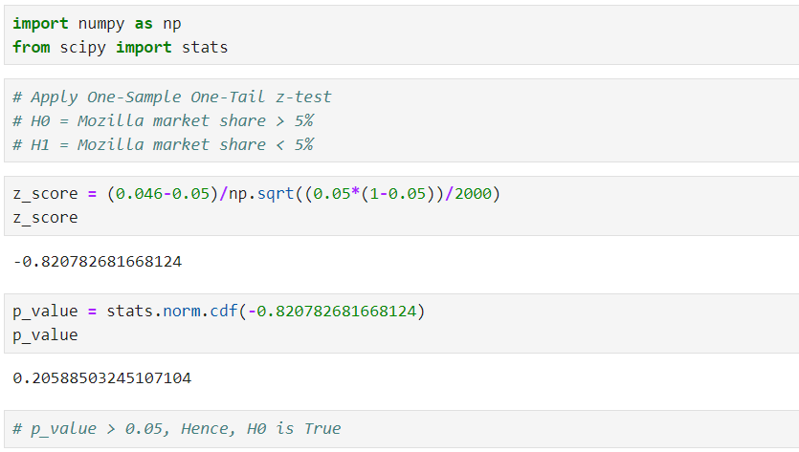

1. WebSideStory claims that its sample includes all the daily Internet users. If that’s the case, then can Microsoft conclude that Mozilla has a less than 5% share of the market?

True.

We are given that WebSideStory claims that its sample includes all the daily Internet users.

That means, 4.6% is population mean. And it is obviously less than 5% share of the market.

1. A book publisher monitors the size of shipments of its textbooks to university bookstores. For a sample of texts used at various schools, the 95% confidence interval for the size of the shipment was 250 ± 45 books. Which, if any, of the following interpretations of this interval are correct?
2. All shipments are between 205 and 295 books.

Incorrect.

Only 95% of shipments are in range of 205 to 295.

1. 95% of shipments are between 205 and 295 books.

Incorrect

95% is CI for size of shipment. But not for individual shipments.

1. The procedure that produced this interval generates ranges that hold the population mean for 95% of samples.

Correct

1. If we get another sample, then we can be 95% sure that the mean of this second sample is between 205 and 295.

Correct

1. We can be 95% confident that the range 160 to 340 holds the population mean.

Incorrect

1. Which is shorter: a 95% *z*-interval or a 95% *t*-interval for *μ* if we know that σ =s?
2. The z-interval is shorter
3. The t-interval is shorter
4. Both are equal
5. We cannot say

For the standard normal distribution (z-value), the critical value for a 95% confidence interval is approximately 1.96.

For the t-distribution (t-value), the critical value depends on the degrees of freedom (df).

we'll assume a sample size of 30,

For a t-distribution with df = 30 and a 95% confidence interval, the critical value is approximately 2.045.

Comparing the two values, we see that the t-value is slightly higher than the z-value. This is because the t-distribution has heavier tails than the normal distribution, which is accounted for by using a larger critical value to achieve the same level of confidence.

In summary, at a 95% confidence interval:

Z-value ≈ 1.96

T-value (df = 30) ≈ 2.045

Questions 8 and 9 are based on the following: To prepare a report on the economy, analysts need to estimate the percentage of businesses that plan to hire additional employees in the next 60 days.

1. How many randomly selected employers (minimum number) must we contact in order to guarantee a margin of error of no more than 4% (at 95% confidence)?
2. 600
3. 400
4. 550
5. 1000

n = P*(1-P) *(z/E)2

n = min. no. of employers

p = estimated proportion of the population that possesses the attribute we're interested in = 0.5 (assume)

z = z-score at 95% confidence (1.96)

E = margin of error

n = 0.5 * (1-0.5) *(1.96/0.04)2

= 600.25

1. Suppose we want the above margin of error to be based on a 98% confidence level. What sample size (minimum) must we now use?
2. 1000
3. 757
4. 848
5. 543

Z (98%) = 2.326

n = P*(1-P) *(z/E)2

n = 0.5*0.5*(2.326/0.04)2

= 846